UNITED STATES OF AMERICA
FEDERAL ENERGY REGULATORY COMMISSION
WBI Energy Transmission, Inc. Docket No. PF26-4-000
NOTICE OF SCOPING PERIOD REQUESTING COMMENTS ON ENVIRONMENTAL ISSUES FOR THE PLANNED
BAKKEN EAST PIPELINE PROJECT,
AND NOTICE OF PUBLIC SCOPING SESSIONS

(May 5, 2026)

The staff of the Federal Energy Regulatory Commission (FERC or Commission) will prepare an environmental document that will discuss the environmental effects of the Bakken East Pipeline Project involving construction and operation of facilities by WBI Energy Transmission, Inc. (WBI Energy) in McKenzie, Dunn, Mercer, Oliver, Burleigh, Kidder, Stutsman, Barnes, and Cass Counties, North Dakota. The Commission will use this environmental document in its decision-making process to determine whether the project is in the public convenience and necessity.

This notice announces the opening of the scoping process the Commission will use to gather input from the public and interested agencies regarding the project. As part of the National Environmental Policy Act (NEPA) review process, the Commission takes into account concerns the public may have about proposals and the environmental effects that could result from its action whenever it considers the issuance of a Certificate of Public Convenience and Necessity. This gathering of public input is referred to as “scoping.” The main goal of the scoping process is to focus the analysis in the environmental document on the important environmental issues. Additional information about the Commission’s NEPA process is described below in the NEPA Process and Environmental Document section of this notice.

By this notice, the Commission requests public comments on the scope of issues to address in the environmental document. To ensure that your comments are timely and properly recorded, please submit your comments so that the Commission receives them in Washington, DC on or before 5:00 pm Eastern Time on June 4, 2026. Comments may be submitted in written or oral form. Further details on how to submit comments are provided in the Public Participation section of this notice.

Your comments should focus on the potential environmental effects, reasonable alternatives, and measures to avoid or lessen environmental effects. Your input will help the Commission staff determine what issues they need to evaluate in the environmental document. Commission staff will consider all written or oral comments during the preparation of the environmental document.

If you submitted comments on this project to the Commission before the opening of this docket on December 23, 2025, you will need to file those comments in Docket No. PF26-4-000 to ensure they are considered.

This notice is being sent to the Commission’s current environmental mailing list for this project. State and local government representatives should notify their constituents of this planned project and encourage them to comment on their areas of concern.

If you are a landowner receiving this notice, a pipeline company representative may contact you about the acquisition of an easement to construct, operate, and maintain the planned facilities. The company would seek to negotiate a mutually acceptable easement agreement. You are not required to enter into an agreement. However, if the Commission approves the project, the Natural Gas Act conveys the right of eminent domain to the company. Therefore, if you and the company do not reach an easement agreement, the pipeline company could initiate condemnation proceedings in court. In such instances, compensation would be determined by a judge in accordance with state law. The Commission does not subsequently grant, exercise, or oversee the exercise of that eminent domain authority. The courts have exclusive authority to handle eminent domain cases; the Commission has no jurisdiction over these matters.

A fact sheet prepared by the FERC entitled “An Interstate Natural Gas Facility On My Land? What Do I Need To Know?” addresses typically asked questions, including the use of eminent domain and how to participate in the Commission’s proceedings. This fact sheet along with other landowner topics of interest are available for viewing on the FERC website (www.ferc.gov) under the Natural Gas, Landowner Topics link.

Public Participation

There are four methods you can use to submit your comments to the Commission. Please carefully follow these instructions so that your comments are properly recorded. The Commission encourages electronic filing of comments and has staff available to assist you at (866) 208-3676 or FercOnlineSupport@ferc.gov.

- You can file your comments electronically using the eComment feature, which is on the Commission’s website (www.ferc.gov) under the link to FERC Online. Using eComment is an easy method for submitting brief, text-only comments on a project;

- You can file your comments electronically by using the eFiling feature, which is also on the Commission’s website (www.ferc.gov) under the link to FERC Online. With eFiling, you can provide comments in a variety of formats by attaching them as a file with your submission. New eFiling users must first create an account by clicking on “eRegister.” You will be asked to select the type of filing you are making; a comment on a particular project is considered a “Comment on a Filing”;

- You can file a paper copy of your comments by mailing them to the Commission. Be sure to reference the project docket number (PF26-4-000) on your letter. Submissions sent via the U.S. Postal Service must be addressed to: Debbie-Anne A. Reese, Secretary, Federal Energy Regulatory Commission, 888 First Street NE, Room 1A, Washington, DC 20426. Submissions sent via any other carrier must be addressed to: Debbie-Anne A. Reese, Secretary, Federal Energy Regulatory Commission, 12225 Wilkins Avenue, Rockville, MD 20852; or

4) In lieu of sending written comments, the Commission invites you to attend one of the public scoping sessions its staff will conduct in the project area, scheduled as follows:

Date and Time | Location
May 19, 2026  5:00 – 7:00 pm Central Time (CT) | McKenzie County Ag Expo  Exhibit Hall 2  12880 25th Street NW  Watford City, ND 58854  (701) 842-3976
May 20, 2026  5:00 – 7:00 pm CT | Hazen City Hall  146 Main Street East  Hazen, ND 58545  (701) 748-2550
May 21, 2026  5:00 – 7:00 pm CT | Lady J’s Club and Catering  930 N. Griffin St.  Bismarck, ND 58501  (701) 221-6836

June 2, 2026  5:00 – 7:00 pm CT | Bunker Hill Venue  1530 3rd St. S.E.  Jamestown, ND 58401  (701) 252-3982
June 4, 2026  5:00 – 7:00 pm CT | @602 Venue  602 2nd St. N.,  Casselton, ND 58012  (701) 347-1622

The primary goal of these scoping sessions is to have you identify the specific environmental issues and concerns that should be considered in the environmental document. Individual oral comments will be taken on a one-on-one basis with a court reporter. This format is designed to receive the maximum amount of oral comments in a convenient way during the timeframe allotted.

Each scoping session is scheduled from 5:00 pm to 7:00 pm CT. You may arrive at any time after 5:00 pm. There will not be a formal presentation by Commission staff when the session opens. If you wish to speak, the Commission staff will hand out numbers in the order of your arrival. Comments will be taken until 7:00 pm. However, if no additional numbers have been handed out and all individuals who wish to provide comments have had an opportunity to do so, staff may conclude the session at 6:30 pm. Please see appendix 1 for additional information on the session format and conduct.

Your scoping comments will be recorded by a court reporter (with FERC staff or representative present) and become part of the public record for this proceeding. Transcripts will be publicly available on FERC’s eLibrary system (see the last page of this notice for instructions on using eLibrary). If a significant number of people are interested in providing oral comments in the one-on-one settings, a time limit of 5 minutes may be implemented for each commentor.

It is important to note that the Commission provides equal consideration to all comments received, whether filed in written form or provided orally at a scoping session. Although there will not be a formal presentation, Commission staff will be available throughout the scoping session to answer your questions about the environmental review process. Representatives from WBI Energy will also be present to answer project-specific questions.

It is important to note that the Commission provides equal consideration to all comments received, whether filed in written form or provided orally at a virtual scoping session.

Additionally, the Commission offers a free service called eSubscription, which makes it easy to stay informed of all issuances and submittals regarding the dockets/projects to which you subscribe. These instant email notifications are the fastest way to receive notification and provide a link to the document files which can reduce the amount of time you spend researching proceedings. Go to https://www.ferc.gov/ferc-online/overview to register for eSubscription.

For public inquiries and assistance with making filings such as interventions, comments, or requests for rehearing, contact the Office of Public Participation at (202) 502-6595 or OPP@ferc.gov.

Summary of the Planned Project

According to WBI Energy, the Bakken East Pipeline Project would provide incremental firm natural gas transportation service connecting North Dakota supply to new power generation, industrial facilities, and local distribution companies in central and eastern North Dakota. The project would interconnect with WBI Energy’s existing natural gas pipeline system and other interstate pipelines along the proposed route to also serve the Midwestern United States.

The Bakken East Pipeline Project would consist of the following facilities:

- 353.1 miles of new 42-inch, 36-inch, and 30-inch-diameter greenfield natural gas pipeline;
- eight new 30-inch, 24-inch, and 20-inch-diameter greenfield natural gas pipeline laterals totaling 21.2 miles;
- additional compression at the existing Spring Creek, Elkhorn Creek, and Mapleton Compressor Stations;
- construction of three new compressor stations (Beulah Compressor Station, Center Compressor Station, and Alliance Compressor Station);
- construction of 6 new receipt stations, 10 new delivery stations, and 8 new interconnect/transfer stations; and
- twenty-eight new mainline valves.

The general location of the project facilities is shown in appendix 2.

Land Requirements for Construction

Construction of the planned facilities would disturb about 8,500 acres of land for the aboveground facilities and the pipeline. Following construction, WBI Energy would maintain about 2,700 acres for permanent operation of the project’s facilities; the remaining acreage would be restored and revert to former uses. Further refinements to the route proposed by WBI Energy as a result of the pre-filing process will likely affect the proposed project acreage. WBI Energy states it will attempt to parallel existing pipeline, utility, or road right-of-way of the planned pipeline route to the extent practicable.

NEPA Process and the Environmental Document

Any environmental document issued by Commission staff will discuss affects that could occur as a result of the construction and operation of the planned project under the relevant general resource areas:
- geology and soils;
- water resources and wetlands;
- vegetation and wildlife;
- threatened and endangered species;
- cultural resources;
- socioeconomics;
- land use;
- air quality and noise; and
- reliability and safety.

Commission staff have already identified several issues that deserve attention based on a preliminary review of the planned facilities and the environmental information provided by WBI Energy. This preliminary list of issues may change based on your comments and our analysis:

- crossing lands owned or maintained by federal and state agencies; and
- crossing navigable rivers and flood control structures.

Commission staff will also evaluate reasonable alternatives to the planned project or portions of the project and make recommendations on how to lessen or avoid effects on the various resource areas. Your comments will help Commission staff identify and focus on the issues that might have an effect on the human environment and potentially eliminate others from further study and discussion in the environmental document.

Although no formal application has been filed, Commission staff have already initiated a NEPA review under the Commission’s pre-filing process. The purpose of the pre-filing process is to encourage early involvement of interested stakeholders and to identify and resolve issues before the Commission receives an application. As part of the pre-filing review, Commission staff will contact federal and state agencies to discuss their involvement in the scoping process and the preparation of the environmental document.

If a formal application is filed, Commission staff will then determine whether to prepare an Environmental Assessment (EA) or an Environmental Impact Statement (EIS). The EA or the EIS will present Commission staff’s independent analysis of the environmental issues. If Commission staff prepares an EA, a Notice of Schedule for the Preparation of an Environmental Assessment will be issued. The EA may be issued for an allotted public comment period. The Commission would consider timely comments on the EA before making its determination on the proposed project. If Commission staff prepares an EIS, a Notice of Intent to Prepare an EIS/Notice of Schedule will be issued once an application is filed, which will open an additional public comment period. Staff will then prepare a draft EIS that will be issued for public comment. Commission staff will consider all timely comments received during the comment period on the draft EIS, and revise the document, as necessary, before issuing a final EIS. Any EA or draft and final EIS will be available in electronic format in the public record through eLibrary and the Commission’s natural gas environmental documents webpage (https://www.ferc.gov/industries-data/natural-gas/environment/environmental-documents). If eSubscribed, you will receive instant email notification when the environmental document is issued.

With this notice, the Commission is asking agencies with jurisdiction by law and/or special expertise with respect to the environmental issues related to this project to formally cooperate in the preparation of the environmental document. Agencies that would like to request cooperating agency status should follow the instructions for filing comments provided under the Public Participation section of this notice. Currently, the Bureau of Land Management will participate as a cooperating agency in the preparation of the environmental document to satisfy its NEPA responsibilities related to this project. Other federal and state agencies are participating in pre-filing activities and may also act as cooperating agencies once WBI Energy files it’s application.

Consultation Under Section 106 of the National Historic Preservation Act

In accordance with the Advisory Council on Historic Preservation’s implementing regulations for section 106 of the National Historic Preservation Act, the Commission is using this notice to initiate consultation with the applicable State Historic Preservation Office, and to solicit their views and those of other government agencies, interested Indian tribes, and the public on the project’s potential effects on historic properties. The environmental document for this project will document our findings on the impacts on historic properties and summarize the status of consultations under section 106.

Environmental Mailing List

The environmental mailing list includes federal, state, and local government representatives and agencies; elected officials; Native American Tribes; other interested parties; and local libraries and newspapers. This list also includes all affected landowners (as defined in the Commission’s regulations) who are potential right-of-way grantors, whose property may be used temporarily for project purposes, or who own homes within certain distances of aboveground facilities, and anyone who submits comments on the project and includes a mailing address with their comments. Commission staff will update the environmental mailing list as the analysis proceeds to ensure that Commission notices related to this environmental review are sent to all individuals, organizations, and government entities interested in and/or potentially affected by the planned project.

If you need to make changes to your name/address, or if you would like to remove your name from the mailing list, please complete one of the following steps:

- Send an email to GasProjectAddressChange@ferc.gov stating your request. You must include the docket number PF26-4-000 in your request. If you are requesting a change to your address, please be sure to include your name and the correct address. If you are requesting to delete your address from the mailing list, please include your name and address as it appeared on this notice. This e-mail address is unable to accept comments.

OR

- Return the attached “Mailing List Update Form” (appendix 3).

Becoming an Intervenor

Once WBI Energy files its application with the Commission, you may want to become an “intervenor,” which is an official party to the Commission’s proceeding. Only intervenors have the right to seek rehearing of the Commission’s decision and be heard by the courts if they choose to appeal the Commission’s final ruling. An intervenor formally participates in the proceeding by filing a request to intervene pursuant to Rule 214 of the Commission’s Rules of Practice and Procedures (18 CFR 385.214). Motions to intervene are more fully described at https://www.ferc.gov/how-intervene. Please note that the Commission will not accept requests for intervenor status at this time. You must wait until the Commission receives a formal application for the project, after which the Commission will issue a public notice that establishes an intervention deadline.

Additional Information

Additional information about the project is available on the FERC website (www.ferc.gov) using the eLibrary link. Click on the eLibrary link, click on “General Search” and enter the docket number in the “Docket Number” field. Be sure you have selected an appropriate date range. For assistance, please contact FERC Online Support at FercOnlineSupport@ferc.gov or toll free at (866) 208-3676, or for TTY, contact (202) 502-8659. The eLibrary link also provides access to the texts of all formal documents issued by the Commission, such as orders, notices, and rulemakings.

Public sessions or site visits will be posted on the Commission’s calendar located at https://www.ferc.gov/news-events/events along with other related information.

(Authority: 18 CFR 2.1)

Debbie-Anne A. Reese,
Secretary.

Appendix 1

Session Format
FERC is conducting the session to solicit your scoping comments. There will not be a formal presentation by Commission staff; however, FERC staff is available to answer questions about the environmental review process. The session format is as follows:
- Tickets are handed out on a “first come, first serve” basis starting at the time listed in the Notice.
- Individuals are called in ticket number order to provide oral comments to be transcribed by a court reporter for the public record.
- Time limits on oral comments may be enforced to ensure that all those wishing to comment have the opportunity to do so within the designated session time.
- Written comments may be submitted in addition to, or in lieu of, oral comments.
- Additional materials about FERC and the environmental review process are available at information stations at the session.
Session Conduct
Proper conduct will help the sessions maintain a respectful atmosphere for attendees to learn about the FERC Environmental Review Process and to be able to provide comments effectively.

- Loudspeakers, lighting, oversized visual aids, or other visual or audible disturbances are not permitted.
- Disruptive video and photographic equipment may not be used.
- Conversations should be kept to a reasonable volume. Attendees should be respectful of those providing oral comments to the court reporters.
- Recorded interviews are not permitted within the session space.
- FERC reserves the right to end the session if disruptions interfere with the opportunity for individuals to provide oral comments or if there is a safety or security risk.

Appendix 2

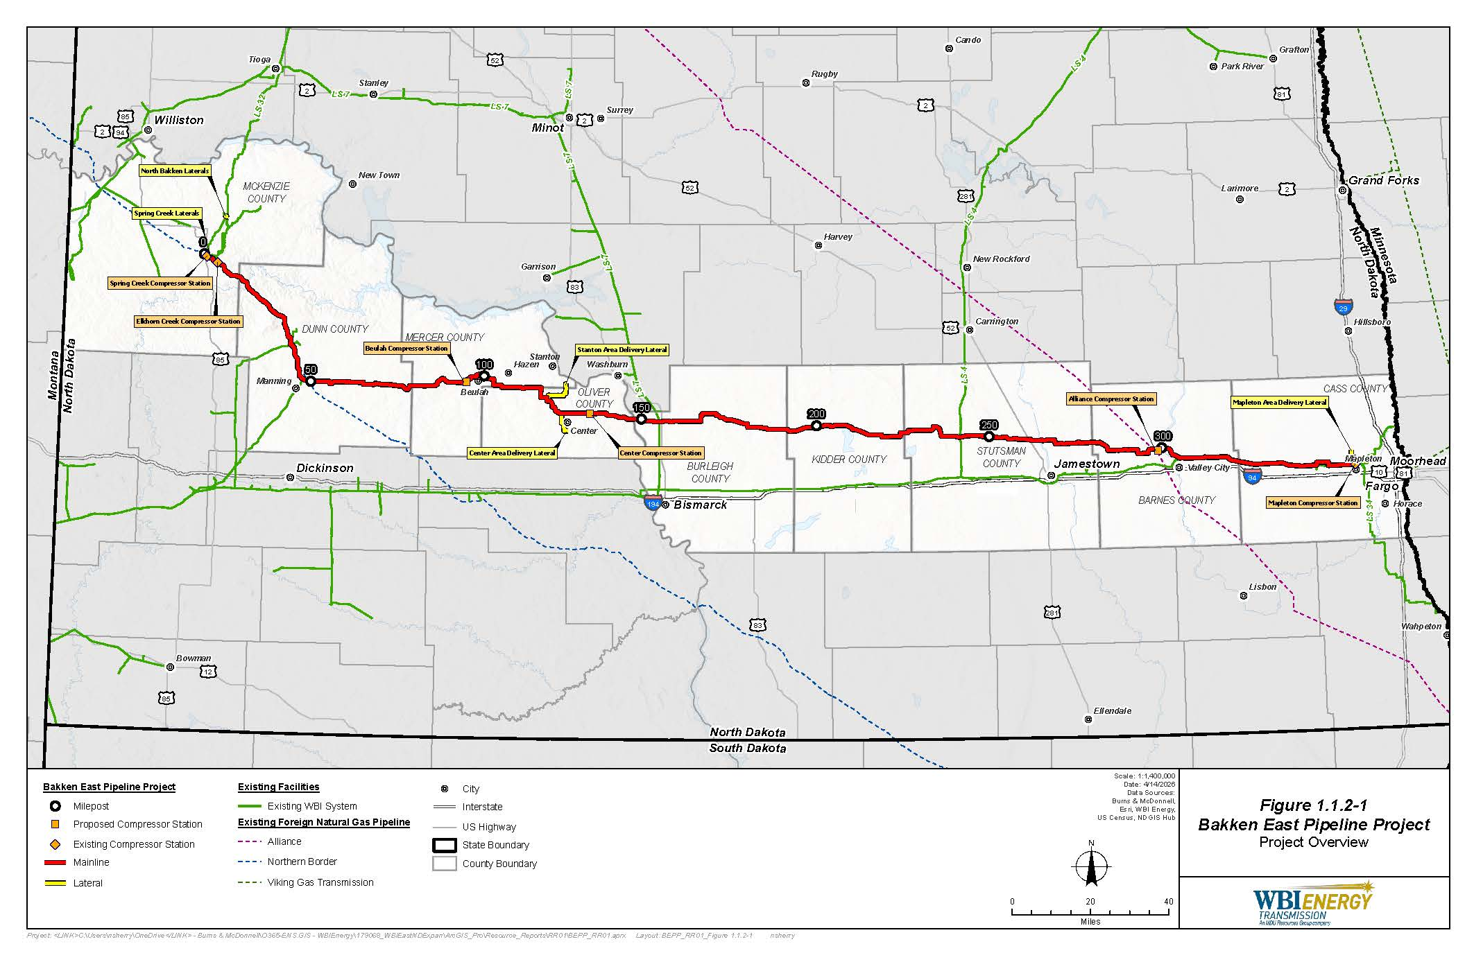

Appendix 3

MAILING LIST UPDATE FORM
Bakken East Pipeline Project

Name
Agency
Address
City State Zip Code

□ Please update the mailing list
□ Please remove my name from the mailing list

FROM

ATTN: OEP - Gas 1, PJ - 11.1
Federal Energy Regulatory Commission
888 First Street NE
Washington, DC 20426

Docket No. PF26-4-000
Bakken East Pipeline Project

Staple or Tape Here

The appendices referenced in this notice will not appear in the Federal Register. Copies of the appendices were sent to all those receiving this notice in the mail and are available at www.ferc.gov using the link called “eLibrary.” For instructions on connecting to eLibrary, refer to the last page of this notice. For assistance, contact FERC at FERCOnlineSupport@ferc.gov or call toll free, (886) 208-3676 or TTY (202) 502-8659.
For instructions on connecting to eLibrary, refer to the last page of this notice.
Cooperating agency responsibilities are addressed in Section 107(a)(3) of NEPA (42 U.S. Code § 4336(a)(3)).
The Advisory Council on Historic Preservation regulations are at Title 36, Code of Federal Regulations, Part 800. Those regulations define historic properties as any prehistoric or historic district, site, building, structure, or object included in or eligible for inclusion in the National Register of Historic Places.

